**Lab Manual 4**

**Lab Task**

Name: Ahmad Aleem Akhtar

CMS ID: 458945

Task 1:

Code:

#include<iostream>

using namespace std;

int main ()

{

int a, k, sum=0;

cout<<"enter ten numbers "<<endl;

for(k=1; k<=10; k++)

{

cin>>a;

sum=sum+a;

}

cout<<"the sum of the ten numbers is "<<sum;

return 0;

}

Output Screen:

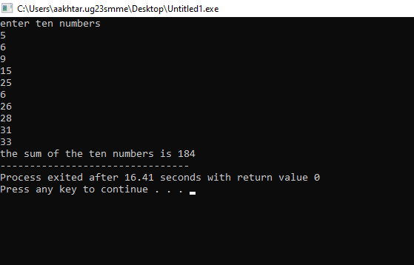

Task 2:

Code:

#include<iostream>

using namespace std;

int main ()

{

int n, p, k;

cout<<"enter a number"<<endl;

cin>>n;

for(k=1;k<=10;k++)

{

p=n*k;

cout<<n<<" * "<<k<<" = "<<p<<endl;

}

return 0;

}

Output Screen:

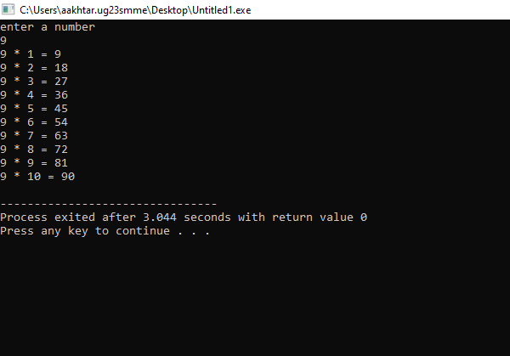

Task 3:

Code:

#include<iostream>

using namespace std;

int main ()

{

int n, k, f;

cout<<"enter a number"<<endl;

cin>>n;

k=1;

f=1;

while(k<=n)

{

f=f*k;

k++;

}

cout<<"the factorial of "<<n<<" is "<<f;

return 0;

}

Output Screen:

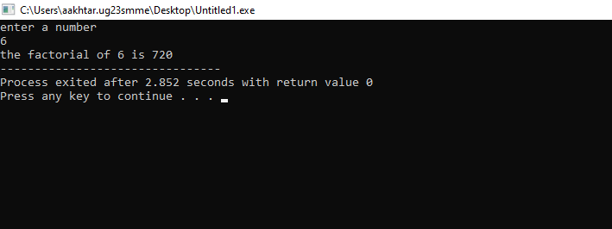

Task 4:

Code:

#include<iostream>

using namespace std;

int main ()

{

int n1, n2, s, k, x=1;

cout<<"enter the two numbers from where to start the fibonacci sequence "<<endl;

cin>>n1>>n2;

cout<<"enter the number of terms in the sequence to be printed"<<endl;

cin>>k;

cout<<"The sequence is: "<<endl<<n1<<" "<<n2<<" ";

while(x<=k)

{

s=n1+n2;

`if(n1>n2)

n2=s;

else

n1=s;

cout<<s<<" ";

x++;

}

return 0;

}

Output Screen:

